**Team ID** : PNT2022TMID18696

**Team Lead :** Sridhar C

**Team Member** : Praveen P

**Team Member**: Jagadeeswaran P

**Team Member** :Venkatesan M

**Topic** : Fertilizers Recommendation System For Disease Prediction

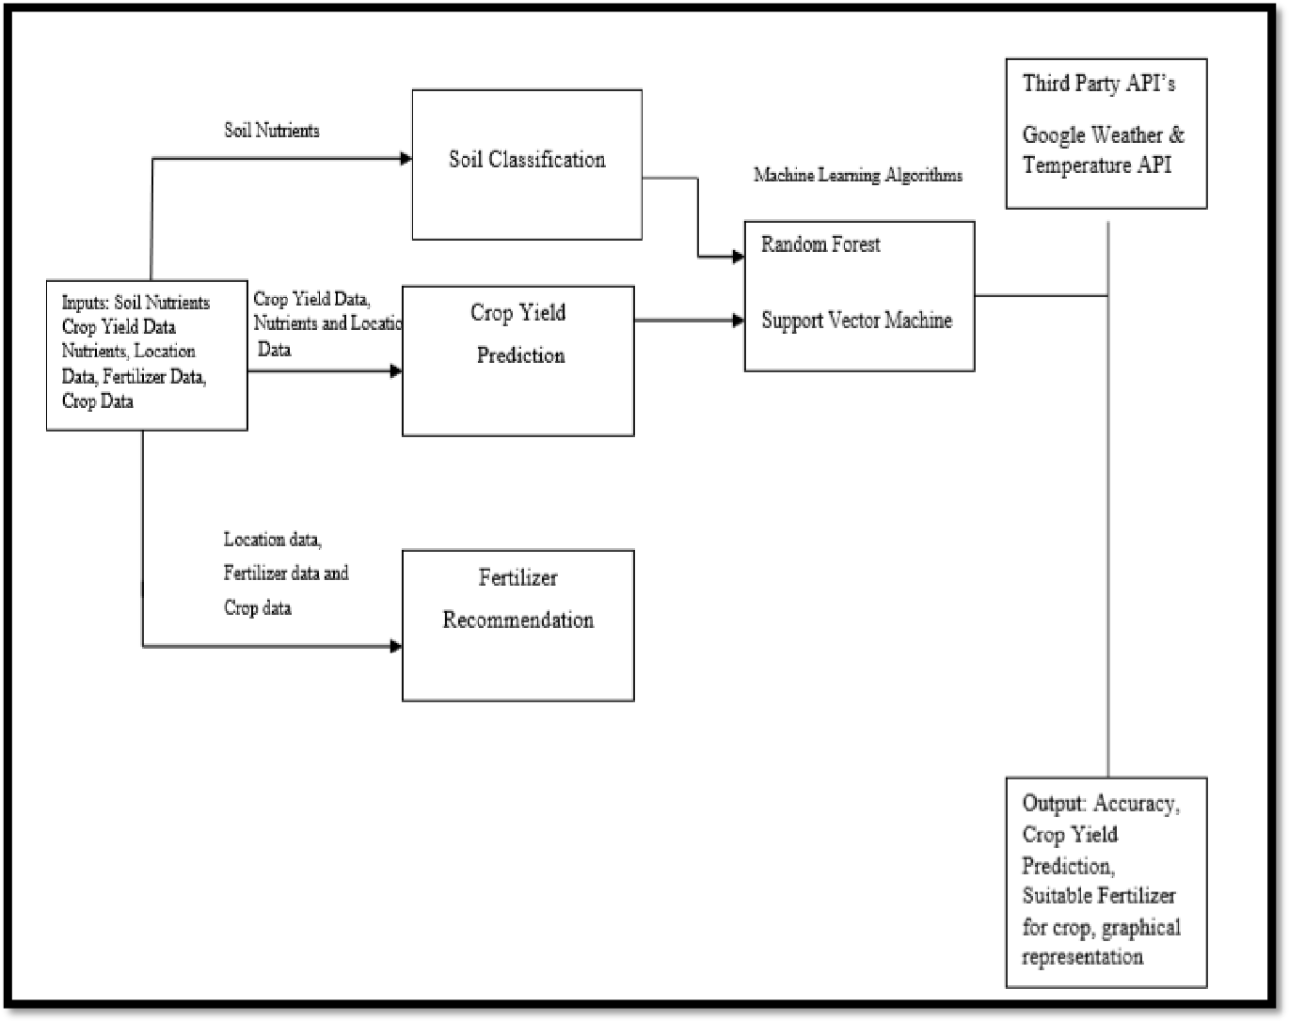

PROJECT STRUCTURE